Performance speed is one of the most pertinent ways in testing the capability of a certain website. It allows the user to validate whether a certain website is loaded in various circumstances and also, how reliable the sources inside the website. Performance Speed in not just about how fast the internet you have, but also, how the website respond to the request of the user. For some instances, the responsiveness of a website falls under the speed performance.

There are a lot of things that are needed to give attention with regard in Performance Speed testing. It is a must that the number of tests is being considered , in order to gather a comprehensive data because the performance of a website is inconsistent and it really depends on the visitor count or in the usage of the server box if you’re on a shared host. The advantage of this is that you can review the peak hours which could indicate the best time for you to post a new content or target add/pop-ups to your user. Another thing that is needed to be considered is that the Test Locations, it really makes a big difference. In testing locally, select a test server near to the physical location of your main server. Aside from this, to test globally, pick several testing servers, preferably 4-5 servers, in key locations around the world. Third is the Test Targets. In performance speed, it is necessary to widen the testing targets, not just only the homepage, but also consider how the other pages may affect the image of the website’s responsiveness to the users.

In performance speed, as a developer, there are a lot of things you need to be aware of, first is the Average page load times, second is the typical size of a certain webpage, the amount of the resources that a standard page loads, lastly, the average server delay that is measured in time to first byte.

According to an article, “The average time it takes to fully load the average mobile landing page is 22 seconds. However, research also indicates 53% of people will leave a mobile page if it takes longer than 3 seconds to load”. This means that it also depends on the user on how he/she can handle the circumstance with regard in using a website.

There are several standards that are followed in testing the Speed performance of a certain website. This article is updated and currently implemented in this year (2018). This article is from MachMetrics Speed blogs that was published last February 25, 2018.

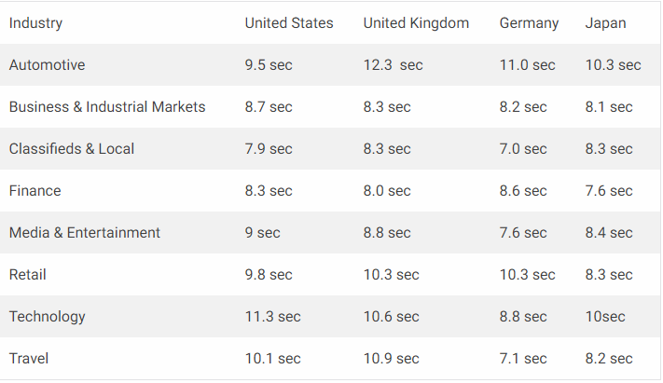

*Figure 1. Average Load Time*

In figure 1 contains the average load time in different countries and in different fields. The minimum average load time as per stated in this figure is in 8.8 seconds, however according to research, the reliable or recommended average load time should be in 3 seconds.

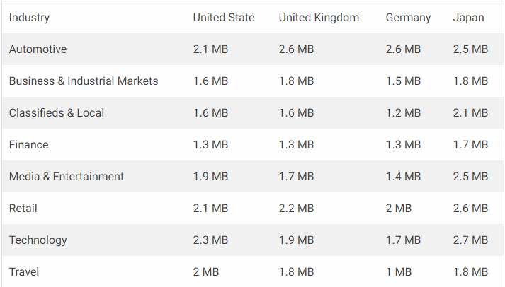

*Figure 2. Average Webpage Size*

In figure 2 contains the average webpage size in different countries and in different fields. The minimum average webpage size Is 1 MB as per stated in the figure but the recommended average webpage size should be under 500 KB.

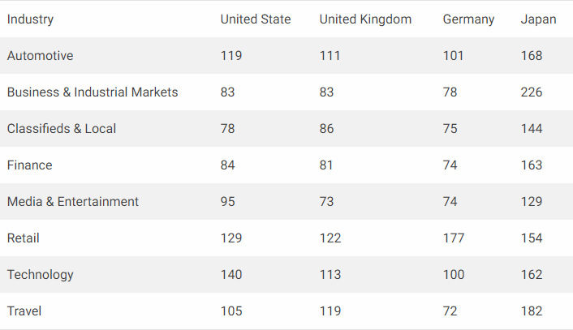

*Figure 3. Average number of Resources*

In figure 3 contains the average number of resources. The minimum average number of resources as per stated in this figure is 78, however the recommended minimum is to be under 50.

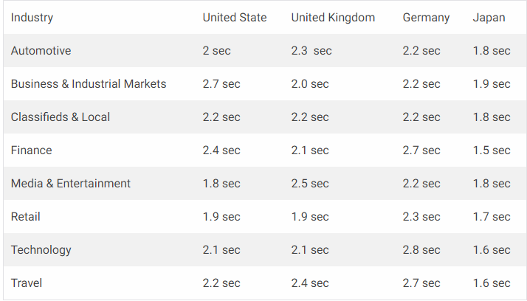

*Figure 4. Average Server Delay*

In figure 4, the average server delay is 1.5 seconds however the recommended should be under 1.3 seconds.

There are several tools in testing the speed performance of a certain website. In this instance, the Website Grader allows you to test the Performance, Security, Search Engine Optimization and Mobile Readiness of your website.

Website Grader is an open source testing tool that can be used by anyone. By its features, you can test whether if the website you have is working on its potential and if it is secured. This tool also provides the error committed by the website and good thing is, Website grader has a feature of providing recommendations for the developer on how he/she can improve the Performance, Security, SEO and Mobile Readiness of the website.

**Website Grader Interface and Comparison of Non-Government Organizations Speed Performance Result:**



*Figure 5. Interface of Website Grader*

The interface of this tool is very user-friendly. You are asked only to enter the website you wanted to test and also, you E-mail Address.



*Figure 6. Testing Haribon Foundation*

**

*Figure 7. Testing Aboitiz Foundation*

**

*Figure 8.Testing Philippine Red Cross*

We will the site of Haribon Foundation as a testing website. This www. Haribon.org.ph is a non -governmental organization that is mainly focused on environmental preservation. The aim of this site is to promote the conservation of our natural resources.

**Summary Result:**

8.PNG

*Figure 9. Summary Result of Haribon Foundation*

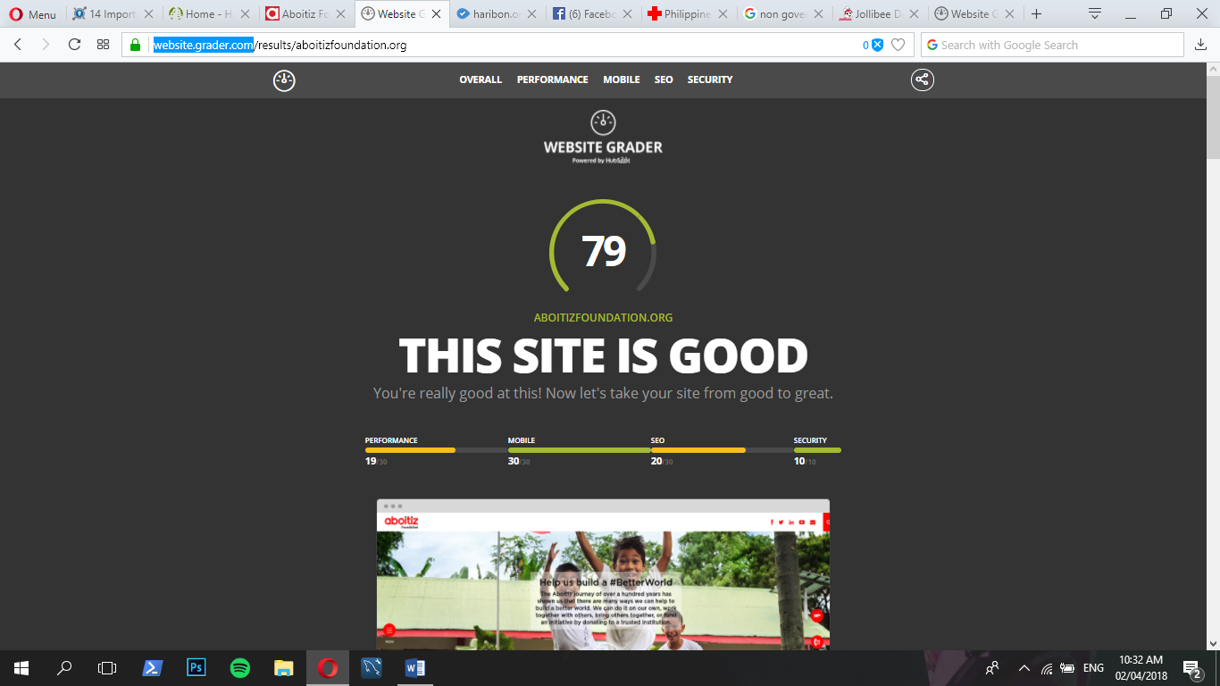



*Figure 10. Summary Result of Aboitiz Foundation*

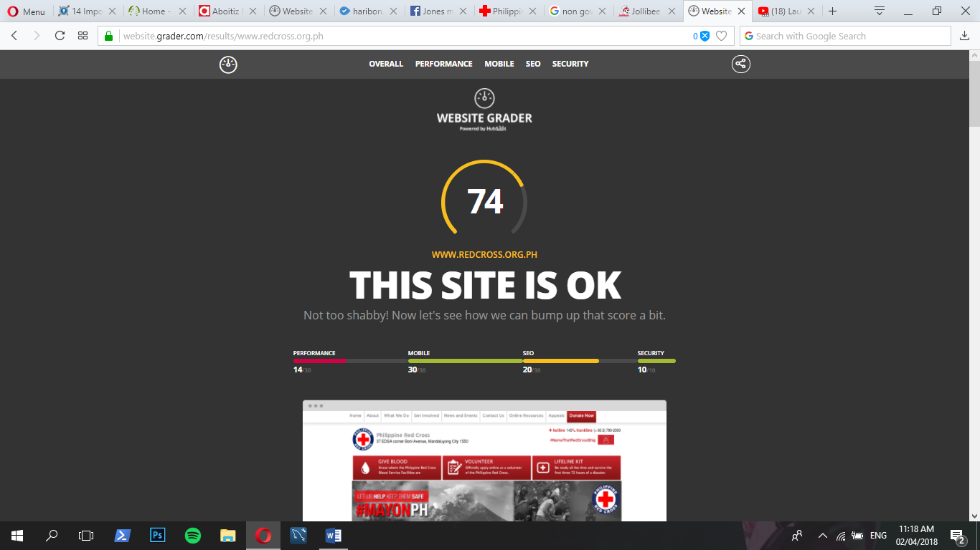



*Figure 11. Summary Result of Philippine Red Cross*

After you input the site you wanted to test, you can immediately see the result. The first score you can see is the overall result which is in the case of the Haribon Foundation site, **it is 69%,** for Aboitiz Foundation, **it is 79%**, and for Philippine Red Cross, **it is 74%.** Below the overall score, you can see the breakdown of these percentages from three compared websites where the score provided by the tool.

Based on Performance:

* **Haribon Foundation -19/30 based on Performance**
* **Aboitiz Foundation-19/30 based on Performance**
* **Philippine Red Cross-14/30 based on Performance**

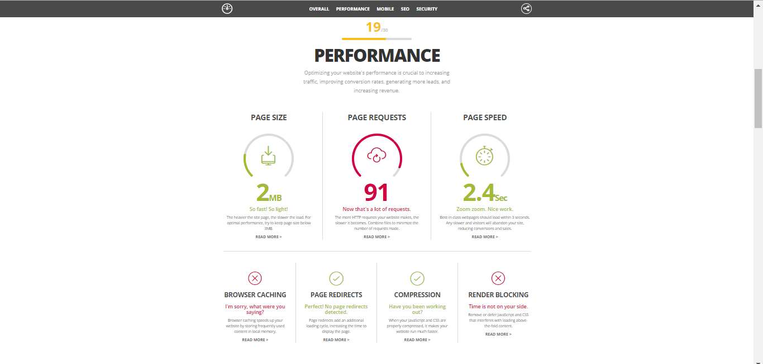

*Figure 12. Performance Result of Haribon Foundation*

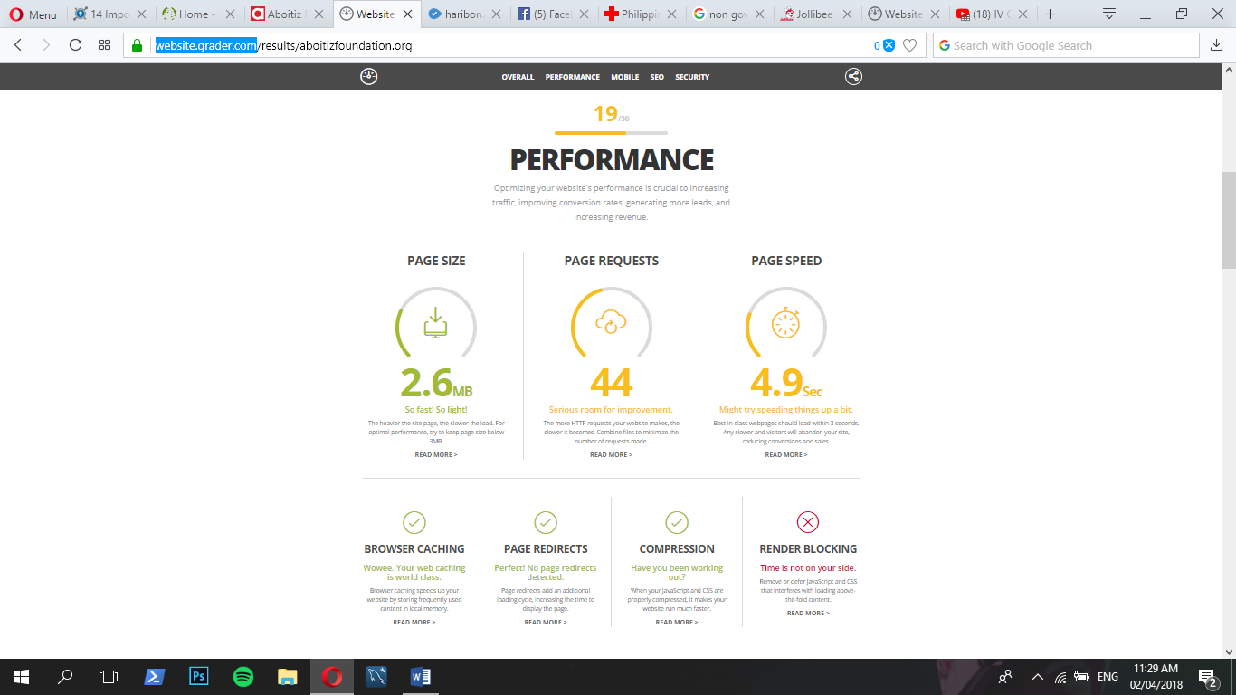

*Figure 13. Performance Result of Aboitiz Foundation*

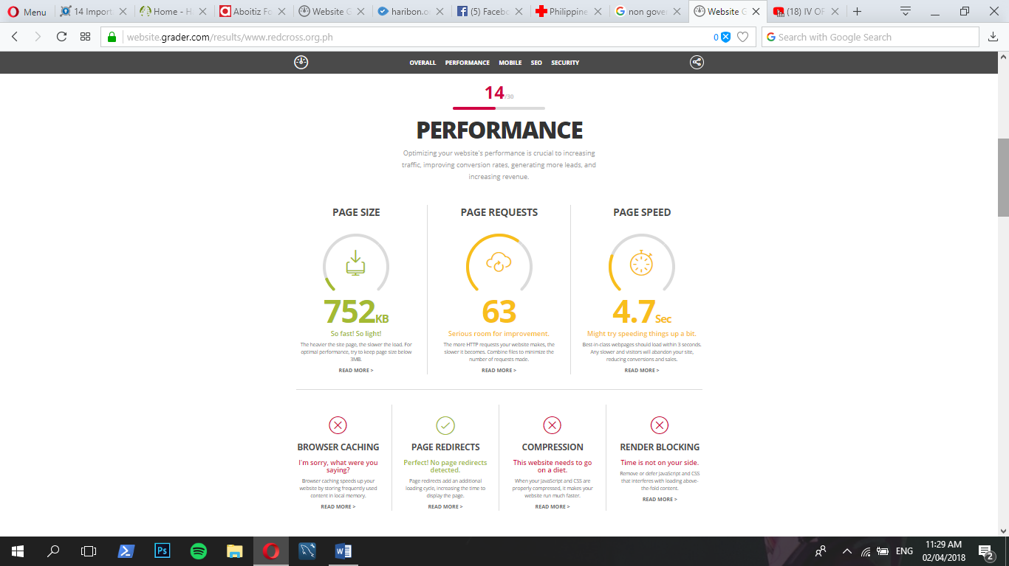

*Figure 14. Performance Result of Philippine Red Cross*

The recommended size of a certain page is below 3 MB. In the case for Haribon Foundation’s site, Aboitiz Foundation and Philippine Red Cross, there is no issue of slow speed in loading their pages. Because of containing the light page sizes, especially for Philippine Red Cross, there is a tendency that the optimal performance of this website might be achieved. Also, based on the result under Page Requests, Haribon Foundation gained 91% wherein in this area, if they have more HTTP requests, the problem is that it will become slower to load.

*Figure 15. Variations of Website’s Page Size*

**NOTE THAT: According to website grader, the heavier the site page, the slower to load it**

The page Request of Haribon Foundation site is in **91%**. Since the Haribon Foundation garnered 91% in HTTP requests, this means that there is a chance that this site is slow in performance.

*Figure 16. Variations of Website’s Page Request*

**NOTE THAT: The more HTTP requests a certain website makes, the slower it will become.**

When it comes to the page speed of Haribon Foundation’s site, there is no issue with regard to this because it only takes **2.4 seconds** to load the page.

*Figure 17. Variations of Websites Page Speed Result*

**NOTE THAT: The average best-in-class web pages are loaded within 3 seconds.**

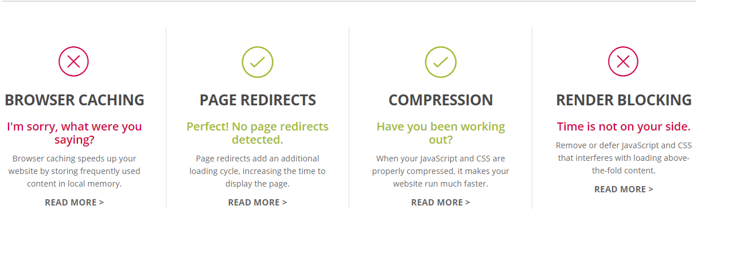

*Figure 18. Results of Haribon Foundation Website*

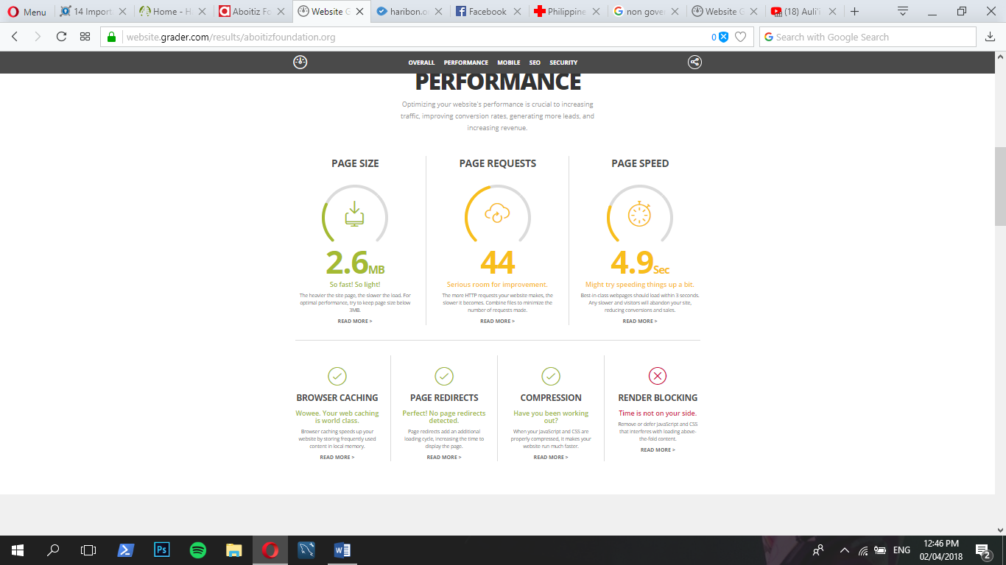

*Figure 19. Results of Aboitiz Foundation Website*

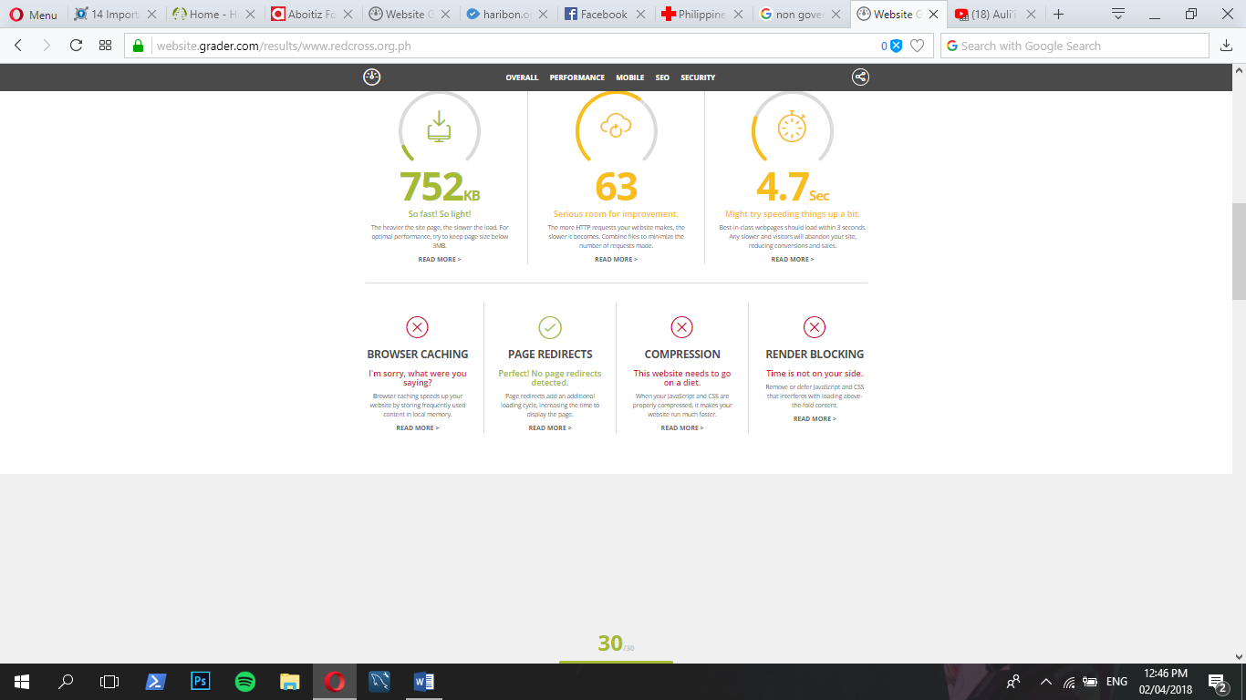

*Figure 20. Result of Philippine Red Cross*

On browser caching, only Aboitiz Foundation made it successful, proven that it stores frequently used content in their local memory which allows browser caching run faster. All three websites are able to comply with Page redirects, which means the pages do not contain other redirects that will make it slower to load for it leads to other pages that is time wasting, if existed. In compression part, Philippine Red Cross seem to need to organize their javaScript and CSS for the website to run faster. Lastly, all of those websites were failed to achieve the Render Blocking where JavaScripts and CSS inside the sites interferes with the above-the-fold contents.

* **MOBILE READINESS – 30/30**

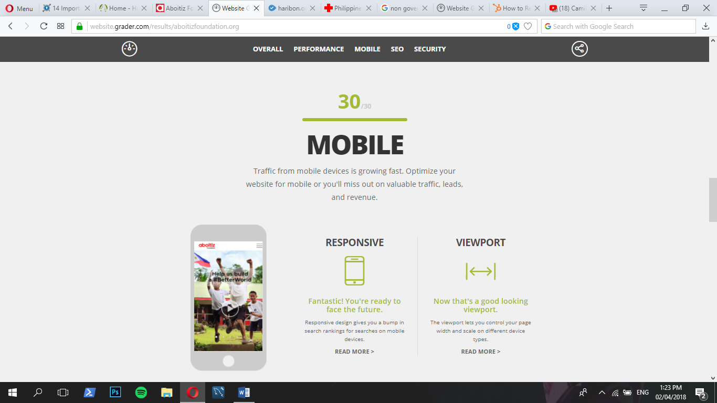*Figure 21. Haribon Mobile Readiness Results*

*Figure 22. Aboitiz Mobile Readiness Results*

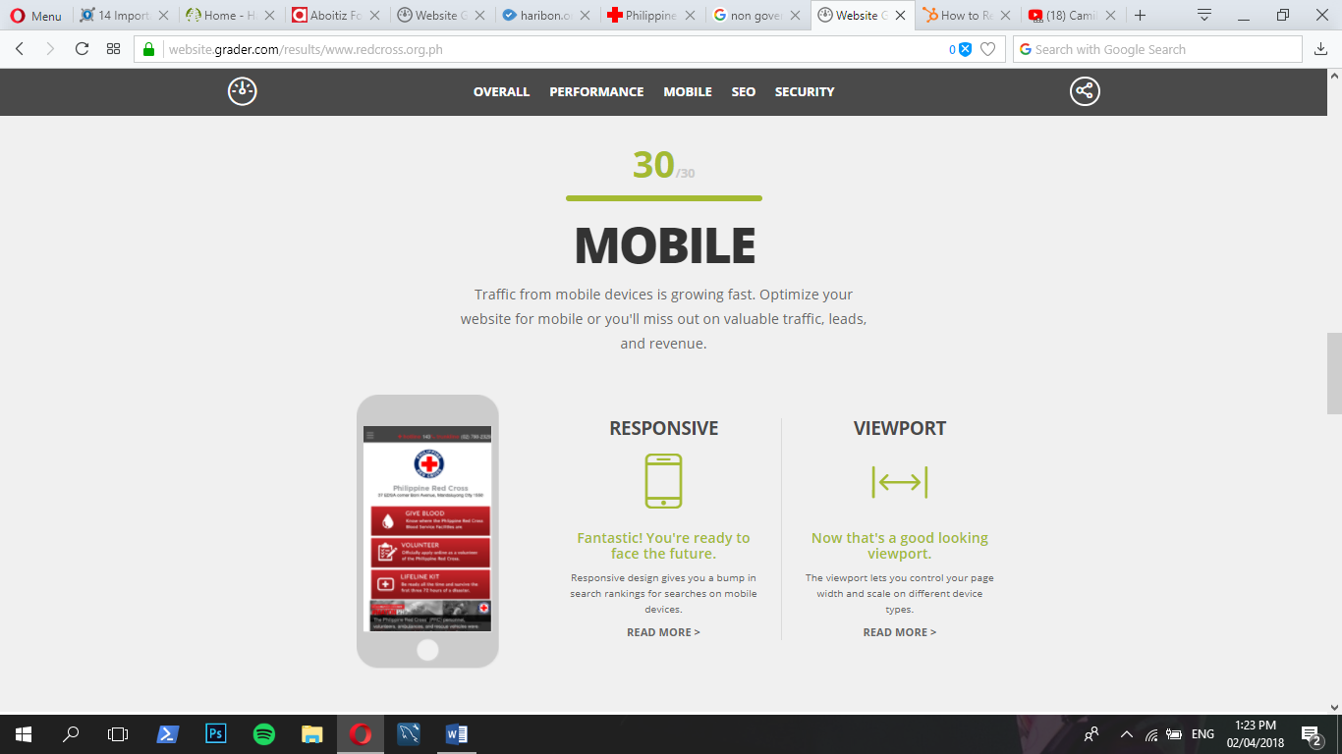

*Figure 23. Philippine Red Cross Mobile Readiness Results*

The Haribon Foundation, Aboitiz Foundation and Philippine Red Cross, all garnered 30/30 in mobile readiness. This means that this site is very responsive and there is no problem whether you’re accessing this site via your desktop or mobile because its viewport is 100% assured that it will fit well on your screen. With regard to responsiveness, that this site has no issue in the responsive design. Meaning, the clickable buttons and the resources that were placed here are working at its best, without hesitation of disarranging the content and sacrificing the speed of the website to load.

In conclusion, Performance Speed testing is necessary in developing a responsive and a reliable website. The potential of a website is determined by the validity of its resources, the contents and security as well. By using the appropriate tools in testing the validity of your site makes it more pertinent and also, more safe to use.

For the three websites that are tested using Web Grader, the performance is quite good with its results. For page size, the three non-government sites achieved the goal to set their page size below 3 mb. With Regard to the HTTP Requests, the developer should reduce it because the 91% result is too heavy. The developer should always check the HTTP requests that are coming in inside the website and limit it by reducing the file size for the remaining images, by combining CSS files and by removing unnecessary images on it. Lastly, with regard to the page speed, since there is no issue on the slow speed of this site, the only recommendation is that the developer should improve this by following the average speed of 3 seconds. In order to do this, the developer of this site should optimize images and css files more and by putting your scripts load before the contents to balance the speed of your website. Performance is not always based on satisfaction of customers, but also how it lightens exerted effort for checking site’s capability and ability to run fast, also to help save time of both developer and user.